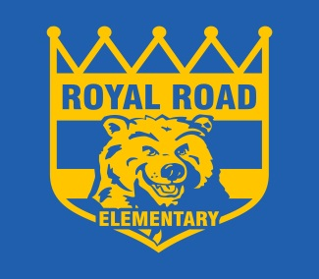
ROYAL ROAD ELEMENTARY SCHOOL
340 Royal Road, Fredericton, NB, E3G 6J9
http://royalroad.nbed.nb.ca
PHONE: (506) 453-5438
FAX: (506) 444-5268
Sheila Legere Principal
Cynthia Burnett Vice- Principal
To Learn, To Grow, To Lead

2016-2017 New Brunswick Elementary Student Wellness Survey

The New Brunswick Student Wellness Survey is a provincial initiative of the Department of Social Development – Wellness Branch, in partnership with the Department of Education and Early Childhood Development and the New Brunswick Health Council (NBHC). The elementary portion of this initiative, the New Brunswick Elementary Student Wellness Survey, began in 2007-2008 and was repeated in 2010-2011 and in 2013-2014. The survey gathers information from students in grades 4 and 5 and parents/guardians of students in grades K to 5. It surveys attitudes and behaviours regarding healthy eating, mental fitness, bullying, physical activity and tobacco use.
By taking the time to complete this survey, students and parents can contribute to their school’s improvement plans and student wellness activities. On Tuesday, February 7th, our school will be participating in this survey, as we aim to improve the health and wellness of children in our community. The parent survey will be sent home on Monday February 6th , please return to the classroom teacher by Friday, February 10th
Participation by students at the time of survey administration will be voluntary and anonymous. Prior to the date of the survey, parents who do not want their child to participate can call the New Brunswick Health Council at 1-877-225-2521 and must provide the school name, student name, homeroom teacher’s name and grade.

If you would like more information on this survey, please call the New Brunswick Health Council at 1-877-225-2521.

